**Social Media Website**

**Vision**

Start Date: 09/03/2020

Author: Daniel Polak

Version: 1.0

1. **Introduction**

Developing a social media website. This website allows users to share photos and posts. The main aim of the website is to provide space where users can interact with each other through posts.

1. **Positioning**
   1. **Business Opportunity**

When people want to meet another

* 1. **Problem Statement**
  2. **Product Position Statement**

1. **Software Overview**

The website must be supported on the most popular browsers (Chrome, Firefox, Opera, Safari and Internet Explorer).

The website must not allow other people to access information of users if they are not registered. It cannot allow other users to see posts of other users if they are not friends.

Users are required to provide their email address, username and password during registration, all other information is optional.

The website must allow the users to share their photos from their local machine to the website which is then stored in a cloud application. It allows the user to update their profile information (Age, Interests, Email, Workplace, School, Relationship Status etc.). Users must be allowed to delete the posts, photos and their own profile.

The system will be made of two parts (see Figure 1):

* **Cloud Application:** Cloud application stores the information received from the users (e.g. photos, posts, general information). It sends this information to the users who are connected/friends with the original user who posted this information.
* **Web Client:** Web Client is used by the users to create profiles, upload photos and create a new post. This data is stored in the cloud application. It allows users to see other users posts and photos if they are connected/friends.

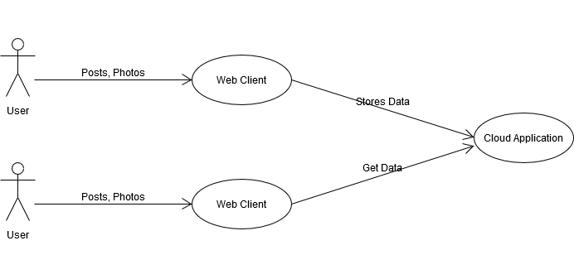

Figure 1 Context Diagram

1. **Summary of Software Features**

* Friend feature – Users can add their friends so they can see the content they posted. Users can also delete a friend.
* Post feature – Users can upload photos and share what they think on the website. Users can delete their photos and posts at any time.
* Profile – Users can add information to their profile (Age, Interests, Workplace, School, Relationship Status etc.), amend existing information and delete the profile.

1. **Main Risks Summary**

* Difficult to schedule for some parts of the project
* More requirements could emerge as the project goes on
* Specification is incomplete or contains conflicting requirements
* Support for multiple browsers is difficult to achieve